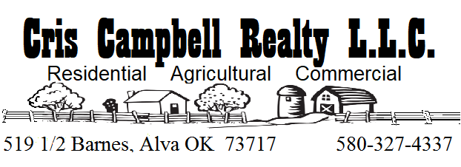

The Seller fully discloses and the Buyer fully understands the Seller is a Licensed Real Estate Broker, licensed by the Oklahoma Real Estate Commission, License Number 111500.
The Seller/Broker purchased the property as a renovation project and has made every effort to restore the property and offer it at fair market value. The Buyer is encouraged to inspect the property and, the Seller/Broker can offer the names and contact information for State Licensed Property Inspectors that work the Alva, Oklahoma market.
The Seller/Broker will conduct himself as a Transaction Agent and will work to ensure a fair deal for all parties.

_____________________ ___________
Buyer’s Signature Date

