1912 Twin Oaks Lane Lafayette, Indiana

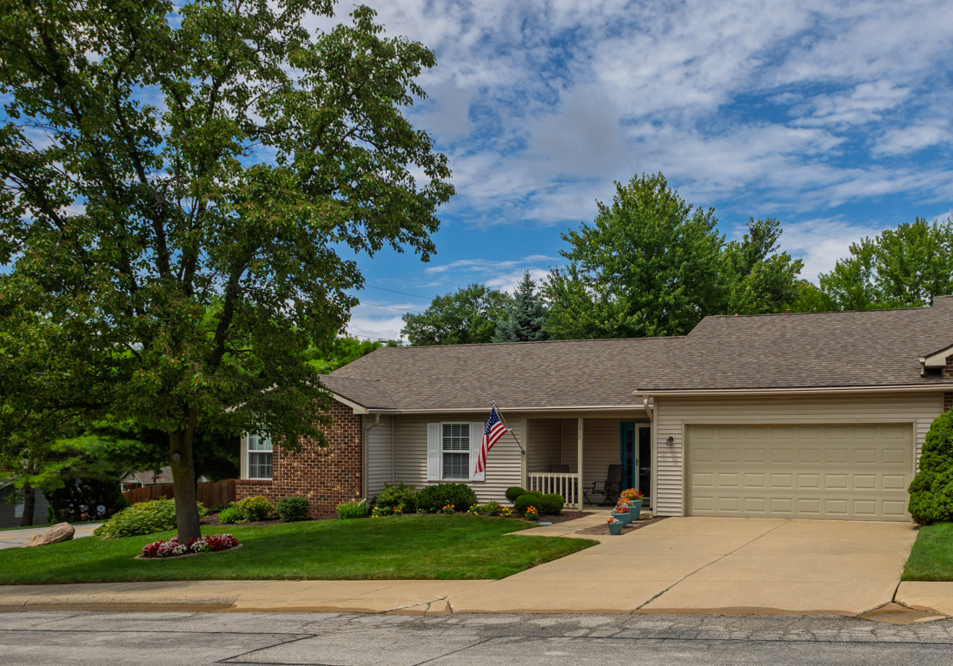
$275,000

Welcome to low-maintenance living in the highly desirable Vinton Highlands area in Lafayette, Indiana. This 1620 square foot, 2-bedroom, 2- full bathroom, ranch style condo offers the perfect blend of comfort, style, and convenience with close access to hospitals, shopping, schools, restaurants, coffee shops, and a short drive to major highways and interstate. Inside, you will find an inviting open-concept layout with gleaming laminate wood floors extending through the living room, kitchen, dining area. The kitchen is both functional and stylish with a breakfast nook island and a pantry just off the hallway. Natural light floods the space thanks to large windows and French doors leading out to the patio, ideal for morning coffee or evening relaxation. A flexible bonus room just off the living room area makes a perfect office, den, or creative space. The spacious primary suite includes a vaulted-tray ceiling, walk-in closet, master bath suite with dual-sink vanity and shower, plus a sky light for warming natural light. A hallway off the kitchen leads to the laundry room and attached 400 square feet two-car garage for added convenience. Enjoy low maintenance living with your mowing, snow removal, and exterior maintenance covered in your monthly HOA dues. This beautifully maintained home offers effortless living in a vibrant, amenity-rich neighborhood.

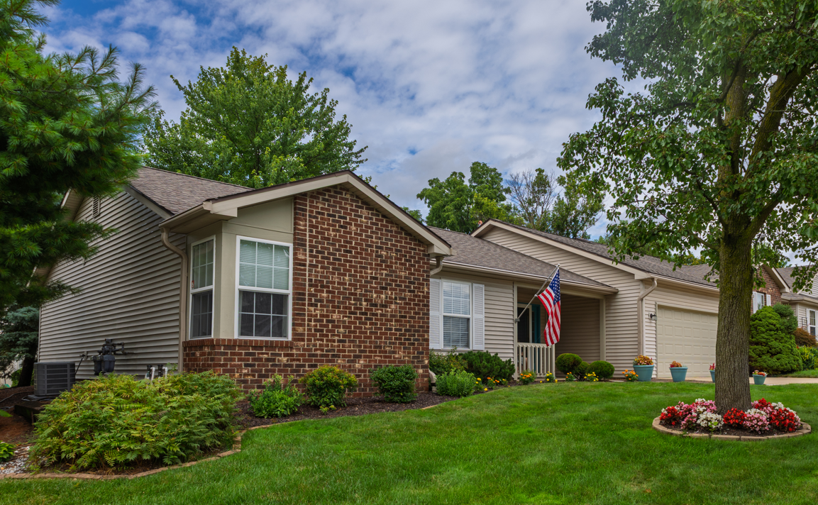
Property Features
- Built 1999
- 1620 square feet of living area
- 400 square feet garage space
- Central air conditioning
- Gas fired furnace
- Gas water heater
- Irrigation system
- Kitchen appliances included
- Gas log fireplace
- Laminate wood floors
- Two full baths
- Vaulted ceilings
- Walk-in closet
- Open patio
- $300 HOA fee
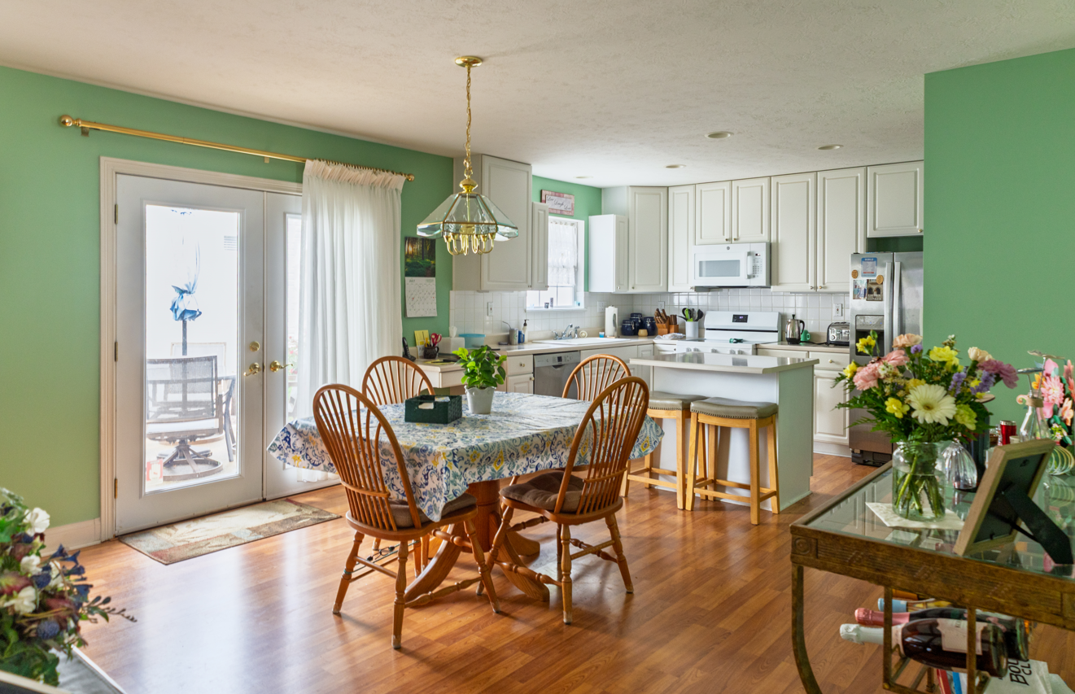

Property Distances
- Purdue University - 12 minutes
- Frankfort, IN - 30 minutes
- Lebanon, IN - 37 minutes
- Indianapolis, IN - 1 hour
- Chicago, IL - 2 hours

School Information
- Elementary School: Glen Acres
- High School: Jefferson
- Middle School: Sunnyside/Tecumseh
- School District: Lafayette

