1 COLLINS ST, CHATEAUGAY, NY 12920
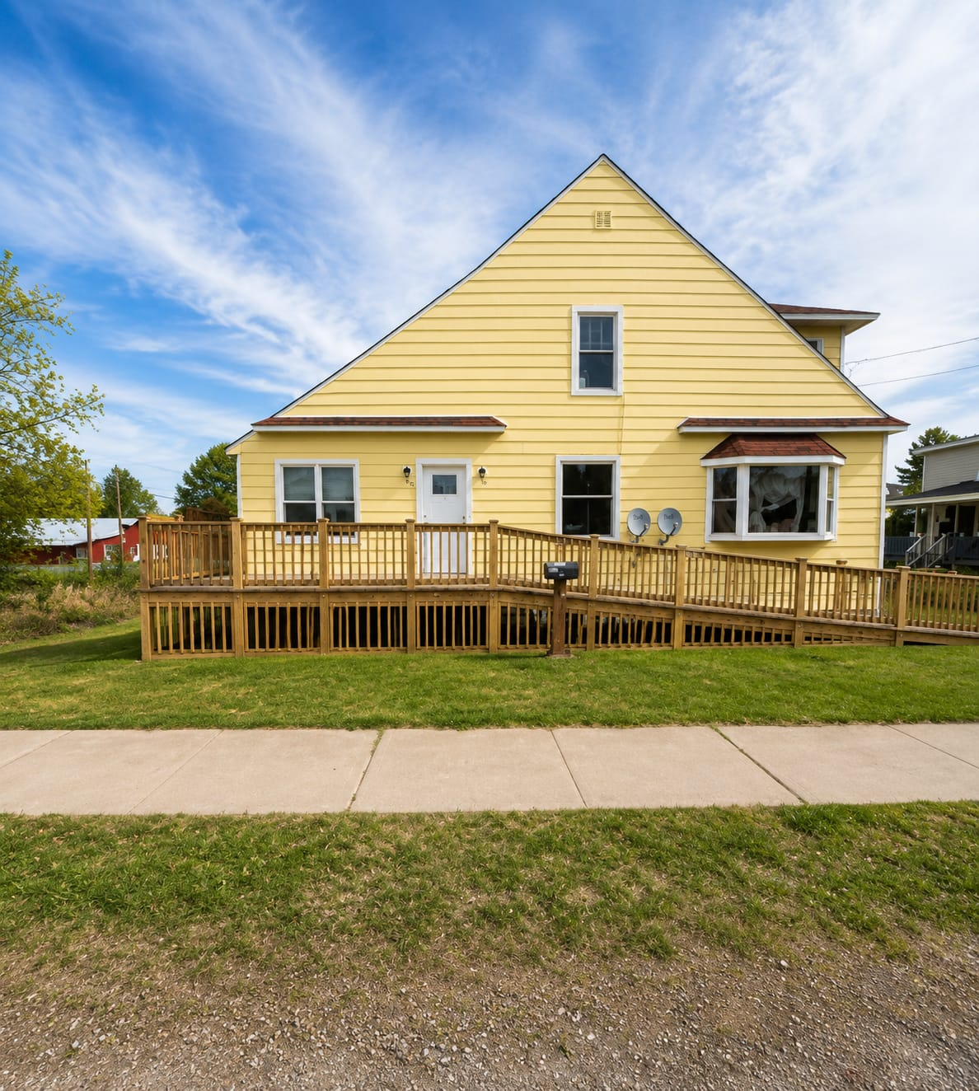
This home, like a majority of the homes in our office's inventory, is a foreclosure.
No inspections have been done on this home and there is no known history due to the fact that it is a foreclosure.
The only things known about this home are things that we have observed by viewing the home. All due diligence is up to the buyer.
This home will be sold as-is, but the seller may elect to perform small property preservation measures to prevent new or further damage.
There are no disclosures or other documentation for this home or other foreclosures. This includes a Property Condition Disclosure. Corporate sellers are exempt due to the fact that they have never seen or occupied the home. No credit is given in lieu.
The seller will not accept lowball offers on this home (or any other foreclosed homes for the most part), but they may choose to evaluate the price on a monthly basis and reduce the asking price by $5,000 to $10,000 per month until it sells.
Anyone interested in making an offer must view the home in person. Sight-unseen offers will not be accepted by the seller. The home must be on the market for seven days before the seller will look at any offers.
Closing timeframes for this and most other foreclosure properties will be about the same or faster than a typical sale. This property is not a short sale.
All liens and/or back taxes (if they exist) will be taken care of by the seller prior to closing on this and other foreclosure properties. Oftentimes any issues present are taken care of prior to the property being listed for sale.

Feedback from buyers and agents specific to this home and/or things we have observed:
The home is in poor overall condition and will require significant repair and renovation throughout. Extensive water damage and possible mold-like substance growth were observed in multiple areas of the home, including ceilings, walls, and flooring. Several rooms contain heavy debris, damaged materials, and deteriorated finishes.
The kitchen, bathrooms, and most interior spaces will require substantial updating or replacement. Portions of the ceilings appear collapsed or heavily damaged from long-term moisture intrusion. Buyers should expect repairs to drywall, flooring, insulation, trim, fixtures, and other cosmetic and structural components.
The condition of the roof, plumbing, electrical, HVAC, furnace, foundation, and other major systems is unknown.
The power is not on at this home. The seller will not dewinterize and rewinterize for inspections, and they will not turn on the power or water.
The exterior shows deferred maintenance in several areas, including portions of the deck and siding. Property preservation or cleanup may be needed both inside and outside the home.

Commission Details:
Per seller instructions, all initial offers must be submitted by the selling agent through PropOffers.com.
The commission paid to the selling agent is 2.00% less $200.00 (plus applicable sales tax) or $1,000.00 less $200.00 (plus applicable sales tax), whichever is greater. Additional technology and offer management fees charged by Pyramid Platform may apply at closing.

How to Make an Offer:
All offers must be submitted through PropOffers.com by the selling agent only. Buyers without representation may contact the listing agent directly for assistance.
If you are an agent and have further questions, please text or email the listing agent. If you are a buyer, please contact your agent if you have one, or the listing agent if you do not.
I receive several hundred calls per week, and it is much easier for me to keep track of correspondence if I have it in writing via text or email.
If you are a buyer, are not currently working with an agent, and would like to make an offer through the listing agent, please contact the listing agent.
Book a showing here: https://calendly.com/breiaj79/1-collins-st

